***C:\Users\Jelena\Desktop\logo mtv.jpgC:\Users\Jelena\Desktop\index.jpg***

***LOCAL ROADS CONNECTIVITY PROJECT***

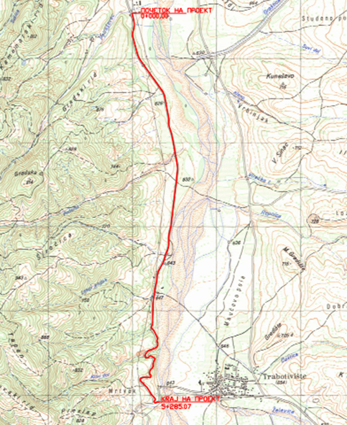

December 2020

ENVIRONMENTAL AND SOCIAL MANAGEMENT PLAN (ESMP)

***Upgrading of local road L-1 connecting Delcevo - Trabotivishte, in Municipality of Delcevo***

Prepared by:

Slavjanka Pejchinovska-Andonova, MSc, Environmental Engineer

Environmental and Social (E&S) Specialist

**TABLE OF CONTENTS**

1. INTRODUCTION 2

2. PROJECT DESCRIPTION 3

2.1 Baseline condition of Municipality of Delcevo 3

2.1.1 Demography 3

2.1.2 Climate features 4

2.1.3 Seismology 5

2.1.4 Water 5

2.1.5 Air quality 5

2.1.6 Waste 6

2.1.7 Geology and soil 6

2.1.8 Flora and fauna 6

2.1.9 Noise 9

2.1.10 Cultural heritage 9

2.2 Project location 9

2.3 Project Activities 10

2.4 Sensitive receptors 11

3. POTENTIAL ENVIRONMENTAL IMPACT AND RISK AND IMPACT AND RISK ASSESSMENT 11

Implementation of ESMP 13

Public disclosure and citizen engagement 15

4. ENVIRONMENTAL AND SOCIAL MITIGATION PLAN 18

5. ENVIRONMENTAL AND SOCIAL MONITORING PLAN 22

6. ANNEX 27

Figure 11 Location of Monument of Nature “Crna Topola S.Machevo” related to project location 27

**FIGURES**

Figure1 Location of the project area in relation with the Municipality of Delcevo 3

Figure 2 Map with potential natural hazards (erosion, floods, landslides and earthquakes) in RNM 4

Figure 3 Project location regarding the watershed of river Bregalnica 5

Figure 4 Paleontological site Stamer 7

Figure 5 Speleological object Mineral cave 8

Figure 6 Specific geological profile of the village Zvegor 8

Figure 7 Location of the upgrading of local road L1 Delcevo - Trabotivishte 10

Figure 8 Location of IPA “Pehchevo wet meadows” related to project location 27

Figure 9 Location of IBA “Osogovo” related to project location 27

Figure 10 Location of Emerald site “Maleshevo” related to project location 27

Figure 11 Location of Monument of Nature “Crna Topola S.Machevo” related to project location 27

**TABLES**

Table1 Planned project activities for the upgrading local road L-1 connecting Delcevo – Trabotivishte, Municipality of Delcevo 10

Table 2 The potential impacts and risks during implementation of the project 12

Table 3 COVID-19 considerations in construction/civil works projects recommended by WB 33

**ANNEXES**

Annex 1 Map of sensitive areas in the wider surrounding of the project location in Municipality of Delchevo 27

Annex 2 Layouts of the local road in Municipality of Delcevo 28

Annex 3 COVID-19 considerations in construction/civil works projects 32

Annex 4 Form for submitting comments 38

Annex 5 Grievance Form for whole project implementation period 39

**ABBREVIATIONS**

|  |  |
| --- | --- |
| EIA | Environmental Impact Assessment |
| ESMF | Environmental and Social Management Framework |
| ESMP | Environmental and Social Management Plan |
| ES | Environmental and social |
| ESS | Environmental and social standards |
| IPA | Important Plant Area |
| IBA | Important Bird Area |
| LRCP | Local Road Connectivity Project |
| MoEPP | Ministry of Environment and Physical Planning |
| MOSHA | Macedonian Occupational Safety and Health Association |
| MSC | Macro seismic |
| MoTC | Ministry of Transport and Communications |
| OH&S;  OHS | Occupational Health and Safety |
| PCE | Public Communal Enterprise |
| PPE | Personal protection equipment |
| PIU | Project Implementation Unit |
| RM | Republic of Macedonia |
| RNM | Republic of North Macedonia |
| TMP | Traffic Management Plan |
| WB | World Bank |
| WHO | World Health Organization |

# INTRODUCTION

The transport sector in Republic of North Macedonia is characterized by poor condition of the local roads network, unsatisfactory level of financing of road maintenance on national level and there are weaknesses of international investment in distribution sector and transport sector. Such poor condition of the local roads is as result of lack of financial capacity of the Local Self Government that differs from region to region in the country. Some local roads in the rural areas are in an unacceptable condition with no access to the hospitals, schools and markets so this issue brings social problems as well.

In order to support the municipalities in the Republic of North Macedonia by 70 million Euro investment secured by the World Bank, Ministry of transport and communications will implement the Local Roads Connectivity Project (LRCP) mostly in rehabilitation of existing local road infrastructure (urban / rural streets, regional and local roads), rehabilitation, upgrading, pedestrian paths, street lighting, water drainage and capacity building of the municipal staff.

When preparing these types of projects, according to the national environmental requirements (Law on Environment and secondary legislation), it is necessary to submit a Notification Letter for intention to start the project to the MoEPP which initiates the environmental impact assessment procedure and based on the Opinion, to prepare the EIA Report. If the issued Opinion of the MoEPP is positive and EIA Report has to be prepared.

The prepared EIA Report is in accordance with Article 24 of the Law on Environment (Official Gazette of the Republic of Macedonia No 53/05, 81/05, 24/07, 159/08, 83/09, 48/10, 124/10, 51/11, 123/12, 93/13, 187/13, 42/14, 44/15, 129/15, 192/15, 39/16 and 98/18) and the Rulebook on the Form and Contents of the EIA Report in accordance with the types of activities for which the report is being prepared, as well as in accordance with the entities performing the activity and the scope of activities being performed by the legal and natural entities, the procedure for their approval, as well as the method for keeping of the register of approved reports (Official Gazette of the Republic of Macedonia No 44/13, 111/14).

Since the project in accordance with the national legislation belongs to the Chapter X – Infrastructure projects, item 1 Upgrading of local roads, the EIA Report for the project “Upgrading of local road L1 connecting Delcevo - Trabotivishte”, in Municipality of Delcevo was prepared in December 2019. The EIA Report was approved by the Mayor of the Municipality of Delcevo with Decision that was issued on 25.12.2019 with number UP1 12-381.

The Municipality of Delcevo has prepared an EIA Report and send a copy together with the Decision of its Approval to the MoTC with other technical documents.

In order to address Project’s potential environmental and social concerns in accordance with the requirements of the World Bank Environmental and Social Standards, Environmental and Social Management Framework (ESMF) was prepared for the whole LRCP project in September/October 2019. ESMF issued, as the most appropriate tool for addressing environmental and social aspects of sub-projects identified in the course of project preparation and implementation.

The sub-project Upgrading of local road L-1 connecting Delcevo - Trabotivishte, in Municipality of Delcevo has an aim to improve the road infrastructure in order to provide better connection of the city of Delcevo and village Trabotivishte and is also link to the “Loshana” reservoir, the recreational lake “Sandanski”, the tourist site “ Kulata”, motel “Kula”, tourist site “Sveti Vodi”, as well as more local businesses.

The current state of the road is well-pressed buffer until the end of the section, where the connection to the regional road to village Razlovci is earth road. The current state of the road is in bad condition. Road width is about 5-6 m, with deformed shoulders but functional drainage.

Near the subject location the following places are also located: recreational lake “Sandanski”, the tourist site “Kulata”, motel “Kula”, tourist site “Sveti Vodi”, village Trabotivishte. Along the road, on the right side, there are arable agricultural areas and on the left side is river Bregalnica. The road has a total length of 5,3 km.

According the Main design for the project, the existing road construction consists of a well-pressed buffer until the end of the section. The main project activities will include: clearing the route of shrubs, trees and roots; mechanical cutting of existing asphalt, machine excavation on the ground, excavation of ditches, buffer profiling, clearing and canalization of the drainage canals, placing road base layer, construction of bank with mechanical stabilization, bearing bitumen layer over existing asphalt and compacting all layers of asphalt.

Taking into account the nature of project activities, technical specifications, size of the road, location of upgrading activities, as well as the specifics of the potential environmental impacts during the upgrading of the road from Delcevo to Trabotivishte, ***the Project Upgrading of the road from Delcevo to Trabotivishte in Municipality of Delcevo was classified as project with substantial risks, which requires the preparation of Environmental and Social Management Plan (ESMP) in accordance with the WB environmental and social standards.***

# PROJECT DESCRIPTION

## Baseline condition of Municipality of Delcevo

The municipality of Delcevo is located in the extreme eastern part of the Republic of North Macedonia. It stretches from northwest to southeast. It borders Blagoevgrad in Bulgaria to the east, the municipality of Pehchevo to the southeast, the municipality of Berovo to the south and the municipality of Vinica to the west. Most of the local communities are spread in the Pijanec valley, while a small part on the southern slopes of the Osogovo Mountains, ie in the region of the upper basin of the river Bregalnica.

It covers an area of 422,3 km2. There are 22 settlements on the territory of the municipality. The municipality has good road connection and connect all settlements in the Eastern part of the country with the Republic of Bulgaria. The Municipality has 17,505 inhabitants (revised Census data from 2002).

On Figure1 is presented location of the project site regard the location of the Municipality of Delcevo.

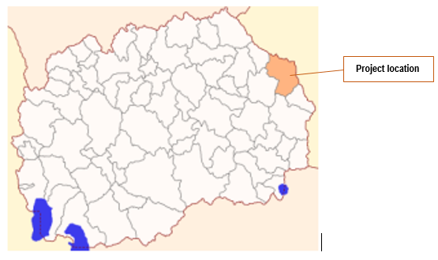

Figure1 Location of the project area in relation with the Municipality of Delcevo

### Demography

According to the 2002 Census, there are 17,505 inhabitants in the municipality of Delchevo, of which 11,536 or 66% live in the municipal center, the city of Delchevo. The average population density is 42.5 inhabitants / km2, which is below the average of the Republic of Macedonia of 78.8 inhabitants/km2. There are 22 settlements in municipality. The average age of the population in the municipality of Delchevo is 36.8 years, and the aging index is 0.414. The total population in the municipality of Delchevo by gender is 51% men and 49% women. The literacy rate is 96.9%.

### Climate features

The climate in Delchevo municipality is Eastern European with modified pluviometer regime. According to meteorological data in Delchevo the average annual air temperature is 10.7 ° C with an absolute minimum of -26.7 ° C and an absolute maximum of 37 °C, while in the mountains the average annual temperature drops to 3.5 ° C. The hottest month is August with an average temperature of 21.6 °C, while the coldest month is January with an average temperature of 0.1 °C.

The average number of rainy days during the year is 71, the average annual amount of precipitation is 548 mm. Precipitation, although relatively low, is favorable during the vegetation period (April -September) and is over 50% of total annual rainfall. The vegetation period with a temperature above 10 ° C lasts 191 days during the year.

Floods and erosion

Municipality of Delcevo is part of Eastern planning region. According to desk research, taking into account the average values of erosion per municipality, the territory of Municipality of Delcevo have about 710 m3/km2/year average value of erosion. This indicate medium level of erosion (medium level of erosion is about 400-800 m3/km2/year). As a result of the current way of land use, there is a pronounced deep and surface erosion, in the entire basin of the river Bregalnica. This process is especially pronounced in the vicinity of the accumulation "Kalimanci", which in one part belongs to the municipality of Delchevo.

In Figure 2 is presented location of the project area regards the potential natural hazards (erosion, floods, landslides and earthquakes) in RNM.

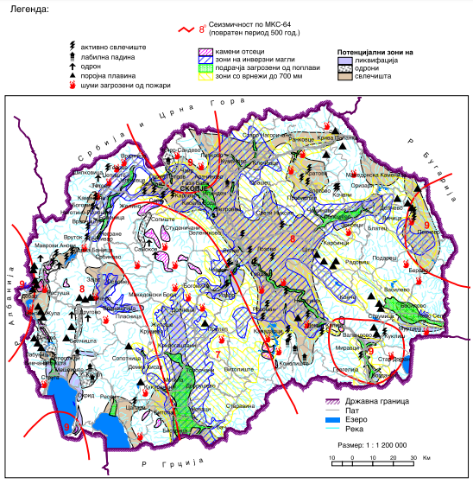

**Project location**

*source:* [*http://app.gov.mk/wp-content/uploads/2015/04/%D0%9030104-PP-na-RM-2002-2020.pdf*](http://app.gov.mk/wp-content/uploads/2015/04/%D0%9030104-PP-na-RM-2002-2020.pdf)

Figure 2 Map with potential natural hazards (erosion, floods, landslides and earthquakes) in RNM

According to Figure 2, the project location in Municipality of Delcevo is characterized as area with low level of risk of flood and landslides.

### Seismology

According to the seismic activity so far, the area of the municipality of Delcevo belongs to areas with significant seismic instability. According to the macroseismic regionalization of the Republic, the territory of the Municipality of Delcevo belongs to the zone with maximum expected seismic intensity VIII - IX ° per MSC.

### Water

The main water artery of the municipality of Delchevo is the river Bregalnica, which is the largest tributary of the river Vardar. The right tributaries of the river Bregalnica are: Zhelevica, Dashtica, Repnica, Grastica, Zvegor River and Gabrovcica. Left tributaries are: Loshana, Petrasevets and Ciflichka River. The total area of the Bregalnica Watershed is 742.5 km2, with an average catchment height of 1000 m. The mean annual flow rate at Razlovci is 6.3 m3/ s. The total annual average flow of Bregalnica on the profile "Kalimanci" is 264 million m3.

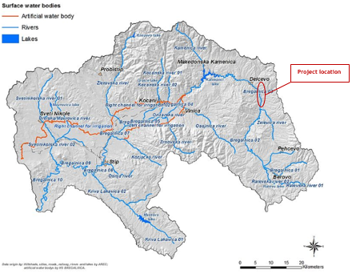

Figure 3 Project location regarding the watershed of river Bregalnica

An important potential hydrographic facility in the municipality is the Loshana dam, with a volume of 1,400,000 m3 of water, near the village of Razlovci, which is in its final phase. This accumulation will mainly be used for complete solution of the water supply problem in the municipality of Delchevo, and partly for irrigation of the Delchevo field (300 ha).

Another significant hydrographic facility constructed in the municipality is the Petrasevac reservoir with a volume of 180,000 m3 of water, which is used for irrigation of arable areas downstream of the dam.

The nearest river is Bregalnica river, located along the project location on a distance from 70 to 300 m to the road, and river Zhelevica which is tributary to river Bregalnica near the end of the project location (in the vicinity of Trabotivishte).

### Air quality

In the Republic of North Macedonia, monitoring of the ambient air quality is performed by the Ministry of Environment and Physical Planning, which manages the State Automatic Air Quality System composed of 17 measuring stations of which 5 are located in Skopje, and the closest measuring station to the project location is the one in City of Kocani, located west from the project location in Municipality of Delcevo. In this air quality measuring station, monitoring is performed of the following: sulphur dioxide, nitrogen dioxide, carbon monoxide, ozone and suspended particles with size of 10 micrometers (PM10)

The sources of suspended particles are burning of fossil fuels and biofuels, different industrial processes, traffic, incineration of waste and wild fires. One of the most important sources is heating of homes and administrative capacities, mainly due to the incomplete incineration of wood in the old furnaces. The number of times the average daily threshold limit value of PM10 at the Kocani measuring point in 2019 was exceeded for 66 days, in the year of 2020 (until June) there were 41 days in which the average daily threshold limit value was exceeded.

In the Republic of North Macedonia, the key and dominant source of sulphur oxides in the air are the processes of burning of fuels (coal and fuel-oil). The average daily SO2 concentrations at this measuring station have not exceeded the threshold value for the year of 2019 and the year 2020 (until June).

Carbon monoxide is formed during the incomplete incineration of fuels in internal combustion engines and energy plants, as well as during different industrial processes, public institutions and households. The maximum daily 8 hour average values of CO concentrations at this measuring station for the year 2019 and the year 2020 (until June) there have not been any exceedance of the threshold value.

The maximum daily 8-hour average values for the ozone concentration in the year 2019 and the year 2020 (until June) there have not been any exceedance of the threshold value. For the 1-hour average values of NO2 there were no exceedances of the upper threshold limit.

### Waste

Deposition of municipal solid wastes, is one of the most serious problems in the Municipality of Delcevo. Organized disposal of municipal and other solid waste is available only in the city Delchevo.

The waste in Municipality of Delcevo is disposed of at the landfill Ostrec approved by the municipality, located at distance of around 5 km from the City of Delcevo. The landfill does not meet the minimum sanitary standards and regulations. The waste is disposed of without any treatment (only leveled and filled with soil and sand). The landfill is maintained by the public utility company "Bregalnica". The landfill is from temporary character, and belongs to the category of so-called "temporary landfills".

There is no organized waste collection, transportation and disposal of municipal waste in the rural areas of the municipality, due to which near rural settlements there are illegal landfills. Waste is disposed in streams and rivers, and more recently along local roads, creating landfills that seriously degrade and endanger the quality of the environment and human health.

Because there is no appropriate alternative landfill for waste disposal from project activities, the generated communal waste should be disposed at landfill Ostrec. Inert waste will be disposed on the municipal inert waste landfill Raleva Chuka.

### Geology and soil

The territory of the Municipality of Delcevo, geologically, belongs to the Vardar structural zone and the Rhodope mass. The terrain is composed of Paleozoic metamorphic and magmatic rocks, mesozoic, tertiary sediments and volcanic rocks.

There are gravels, sand, muscovite clays from alluvial deposits, and most of them are located along the river Bregalnica and its tributaries. There are significant deposits of coal on the territory of the municipality, naturally baked clay, granite and limestone.

### Flora and fauna

Forests in the Municipality of Delchevo cover an area of 27,899 hectares or 48% of the total territory of the municipality. The oak forest is the most represented in the structure of the forests, then the pine forest and finally the beech forest with the lowest percentage. Forests are rich in various medicinal herbs, berries and herbs. Forests in the municipality of Delchevo are deficient in timber - the needs for a particular household tree are greater than the established annual cut-off date. The forests are rich in flora and fauna, and special attention should be paid to following species: wild boar, deer, wild rabbit, black eagle, partridge and owl.

**Protected natural rarities within the Municipality of Delcevo**

1. ***Paleontological site Stamer***

The Stamer paleontological site is rich in Pyramid fossil fauna located in Delchevo region 5 km south-east of Delchevo near the village of Stamer, with a surface area of 25.6 ha. According to the Decision published in the Official Gazette, the Municipality of Delchevo is managed by the Paleontological Site Sumer and in order to prevent damage or destruction of the natural rarity, the municipality undertakes activities for the preservation and maintenance of the natural rarity, as well as protection measures. In this sense, the Municipality can carry out scientific research and monitoring with the permission of the Ministry of Environment and Physical Planning, promotes natural rarity as a tourist destination, signs it with appropriate information boards, conducts educational activities on the need to preserve the site. Implementation of activities and activities within the boundaries of natural rarity, such as the construction of access paths and the arrangement of rest areas, is carried out in a manner that provides a high degree of biodiversity and landscape diversity in order to ensure proper management of natural rarity. The Paleontological Tomb of Pikeermine Fauna has been determined and part of it, scientifically researched 12 years ago, when scientists from the Skopje Museum of Natural History discovered important fossil pike fossils here, such as the unique European skull, giraffe skull, mastodon, fossil fossil, etc, fossils 10 to 3 million years old. source: <https://www.delcevo.gov.mk/en/prirodni-resursi-2>)

[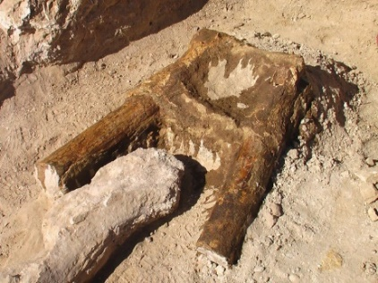](https://www.delcevo.gov.mk/en/prirodni-resursi-2/attachment/stamer1) [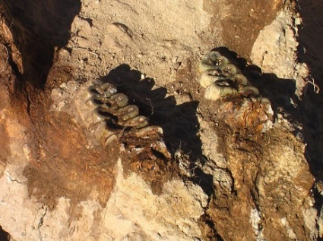](https://www.delcevo.gov.mk/en/prirodni-resursi-2/attachment/retkost_stamer2) [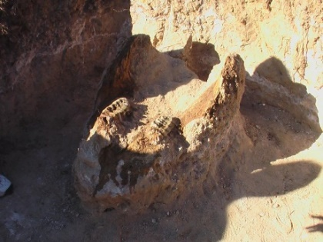](https://www.delcevo.gov.mk/en/prirodni-resursi-2/attachment/retkost_stamer3)

Figure 4 Paleontological site Stamer

1. ***Speleological object Mineral cave***

In accordance with the Law on Nature Protection, the Ministry of Environment and Physical Planning declared it a natural rarity - the speleological object – Kiselica Cave located on the territory of the Municipality of Delchevo, in the village of Kiselica. According to the Decision on Declaration of Natural Rarity, it will be managed by the Municipality of Delchevo, in order to prevent its damage, destruction, as well as to prevent the performance of other activities by natural and legal persons that may directly or indirectly natural rarity is endangered, the mayor undertakes activities to preserve and maintain natural rarity. Protective preventive measures will also be implemented, but activities will be undertaken for arranging the space, setting up information boards, etc. Although relatively small, Kiselichka Cave is significant in many respects. It is a rare recorded cave occurrence in the eastern part of Macedonia, more precisely in the Kraistidian tectonic zone, where only two caves have been registered so far (Kiselichka Cave and Konjska Dupka). It is also significant after its occurrence in a small tectonic block of Triassic limestones, whose distribution is very small in the eastern part of N. Macedonia. (source: <https://www.delcevo.gov.mk/en/prirodni-resursi-2>)

[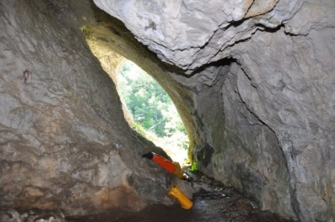](https://www.delcevo.gov.mk/en/prirodni-resursi-2/attachment/kiselichka) [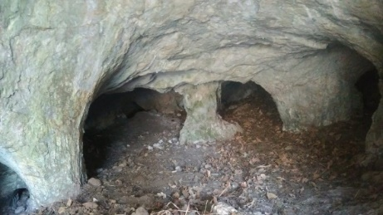](https://www.delcevo.gov.mk/en/prirodni-resursi-2/attachment/kiselicapeshtera2) [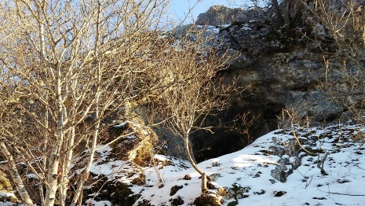](https://www.delcevo.gov.mk/en/prirodni-resursi-2/attachment/peshterakiselica)

Figure 5 Speleological object Mineral cave

1. ***Specific geological profile of the village Zvegor***

The Ministry of Environment and Physical Planning based on the Law on Nature Protection has adopted a Decision granting the status of natural rarity to the characteristic geological profile of Zvegor located about 1 km north of the village Zvegor, at an altitude of 740-850 m.a.s.l. on the eastern slopes of the Ilin Kamen highway to the road leading to the border with the Republic of Bulgaria and covers an area of 7.8 hectares. Natural Rarity A characteristic geological profile - Zvegor is managed by the Municipality of Delchevo, and in order to prevent damage, destruction or overcrowding of the natural rarity, the Municipality will undertake activities to preserve and maintain the natural rarity. (source: <https://www.delcevo.gov.mk/en/prirodni-resursi-2>)

[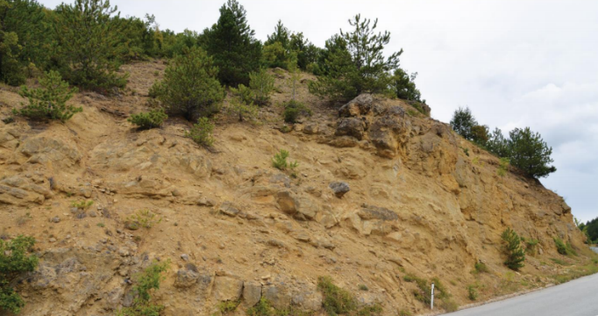](https://www.delcevo.gov.mk/en/prirodni-resursi-2/attachment/zvegor-1) [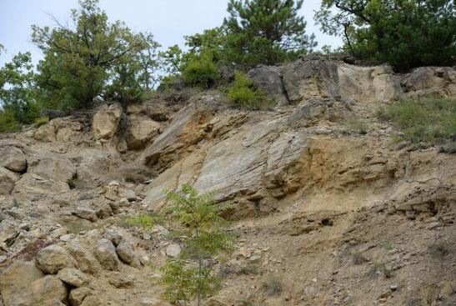](https://www.delcevo.gov.mk/en/prirodni-resursi-2/attachment/zvegor-4)

[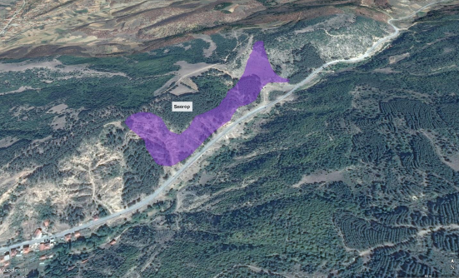](https://www.delcevo.gov.mk/en/prirodni-resursi-2/attachment/zvegor-2)

Figure 6 Specific geological profile of the village Zvegor

In the wider surrounding of the project site are located following protected areas: Important Bird Area (IВA) “Osogovo” (located about 27 km southwest from the project site); Emerald site “Maleshevo” (located about 14 km southeast from the project site); Important Plant Area (IPA) “Pehchevo wet meadows” (located about 16 km southeast from the project site) and Monument of Nature “Crna Topola S.Machevo” (located about 16.2 km southwest from the project site); the project location, are presented in Annex 1.

### Noise

In the RNM only in the bigger cities, the environmental noise is monitored, whereas in the Municipality of Delcevo there is no monitoring station, therefore the noise pollution is not monitored.

There are not recorded any complains about increased level of noise at the project site.

### Cultural heritage

According to the archeological map of the Republic of Macedonia, the East Planning Region is rich in localities. In the proximity of Delchevo there are 112 archeological localities: Bigla 6, Virche 6, Vratislavci 1, Gabrovo 3, Grad 3, Delchevo 8, Dramche 7, Dulica 7, Zvegor 5, Ilievo 2, Kamenica 5, Kiselica 5, Kosovo Dabje 3, Kostin Dol 3, Kosevica 3, Lukovica 2, Moshtica 7, Nov Istevnik 1, Ochipale 5, Razlovci 5, Sasa 9, Selnik 1, Stamer 1, Star Istvenik 3, Todorovci 1, Trabotivishte 5, Turija 1, Crkvenec 3, Chiflik 1. The most important representatives of the cultural heritage in the municipality of Delcevo is archeological locality Gradishte, village Grad – Delchevo; many archeological findings reveal the presence of an important urban settlement since Roman Age in the village Grad.

There are many churches, monastery and mosqueс in the Municiplaity of Delcevo. A protected cultural monument is the church of St. Petka in the village Selnik, dating from the 16th century.

## Project location

The project area, where the project activities for upgrading of local road that connect Delcevo with Trabotivishte will be performed is located in the east part of the Municipality of Delcevo, precisely on the left side of the river Bregalnica providing connection of the agricultural fields with the city of Delcevo and settlement Trabotivishte. This road is a part of the local road infrastructure in the Municipality of Delcevo and has significant importance for the economic development of the municipality.

According the data from the State Statistical Office in 2014, the Municipality of Delcevo was counting 17.505 people. The population in Delcevo is 11.536 people and for Trabotivishte is 530 people. Within the Municipality, around 51,3% are male and 48,7% female. Greater part of the population is from 15 – 64 years old and the main income for the population is from agriculture and industry.

The total length of the project area is 5.300 m. The project area is located in flat terrain with many agricultural fields along the river Bregalnica. The existing local road connects the city of Delcevo with settlement Trabotivishte (project location) and than the road continue to settlement Razlovci. At the subject location the current state of the road is an existing asphalt road with visible damage and variable width (5-6 m) which disable vehicles movement, the shoulders are deformed and the culverts are still functional.

Near the subject location the following places are also located: recreational lake “Sandanski” (1km north of the project location), accumulation Loshana (3,5 km south west from project location), the tourist site “Kulata”, motel “Kula”, tourist site “Sveti Vodi”.

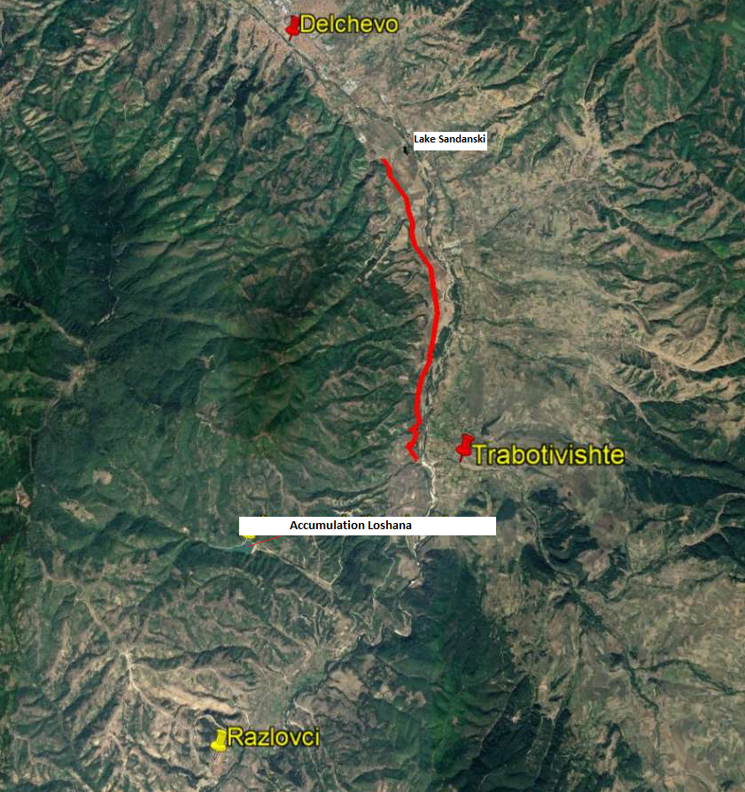

Figure 7 Location of the upgrading of local road L1 Delcevo - Trabotivishte

This sub-project will consist of: clearing the route removing shrubs and roots, marking and securing the route at the project location, removing of existing asphalt, excavation of soil, placing tampon material, placing BHS 16 and shoulders, placing of pipes with Φ600 and Φ400 for drainage.

In accordance with the existing state and the requirements given by the Investor, the subject road is classified as local road. The traffic speed on the local road is planned to be 30 km/h.

## Project Activities

The planned project activities will be performed in three phases: preparatory activities (marking out and clearing up of the project site to be upgraded), upgrading of the local road (installation of crushed stone material, putting asphalt layer, etc.), and operational phase – activities related to regular and preventive maintenance of local road. The layout of the planned upgrading is shown in Annex 2 Layouts of the local road in Municipality of Delcevo. The main project activities are presented in Table 1.

Table1 Planned project activities for the upgrading local road L-1 connecting Delcevo – Trabotivishte, Municipality of Delcevo

| **Local road L-1 connecting Delcevo - Trabotivishte (length = 5,3 km)** | |
| --- | --- |
| **Project phases** | **Project Activities** |
| ***Preparatory activities*** | * Marking and securing the route at the project location; * Removal/ clearance of vegetation along the road; * Mechanical cutting of asphalt pavement; * Coating with unstable emulsion; |
| ***Upgrading phase*** | * Mechanical excavation of soil (loading and transport to landfill) 358 m3 * Compacting the bed to the required compaction; * Mechanical making of embankment obtained from excavation; * Construction of the bank with mechanical stabilization with width 75cm * Making of reinforced concrete culvert ø600; * Making of reinforced concrete culvert ø400 in the area of lateral connections * Placing road base layer; * Spraying of diluted bitumen over the road; * Placing a bearing bitumen layer over existing asphalt; * Placing a secondary layer; * Placing a bearing bitumen layer over new road upgrading; * Compacting a secondary layer of asphalt concrete; |
| ***Operational phase*** | * Clean up the upgrading site; * Regular maintenance (especially in the winter period); |

## Sensitive receptors

During the preparation activities and upgrading phase, sensitive receptors that will be affected, are: workers (who will be engaged during the upgrading phase), local population living in the s. Trabotivishte and s. Razlovci (who will gravitate along the project site toward city of Delcevo) and the people that are working on the agricultural area along the project location. Sensitive objects that need to be taken into consideration during the implementation of the project activities, are the local quarries and the agricultural area. This conclusion is referring in aspect of increased level of noise and air emissions.

Potential environmental impact and risk and impact and risk assessment for each aspect, is given below. The road is used by the communities for transit to bigger urban centers for work (Delcevo, Makedonska Kamenica, Kocani) visit the health centers, attending elementary school, high school or faculty. During implementation of the project activities, the alternative road that will be used by the people is road Delcevo - Pehcevo.

# POTENTIAL ENVIRONMENTAL IMPACT AND RISK AND IMPACT AND RISK ASSESSMENT

According the national legislation, the Environmental Impact Assessment Report for the project was prepared in December 2019. The adoption of the Report was performed by the Mayor of the Municipality of Delcevo, Mr. Goran Trajkovski. The Report contains the main project activities, description of the location where the upgrading activities will be performed, environmental conditions in the project area, main impacts and proposed general environmental mitigation measures.

Increased level of noise, air emissions, possible improper waste management, OH&S risk and risk on local community safety are main identified adverse environmental impacts and risks. Adverse impact on cultural heritage sites are not expected. Detailed analyses of each possible impact and risk is shown below.

Some of the parcels within this project was private owned and for that reason, the process for land acquisition was needed to be implemented by the Municipality of Delcevo. The Municipality of Delcevo all expropriation process has conducted on open and transparent way by informing and including all concerned owners of the land and implementation of all necessary actions. The process was completed in September 2020 with payment of compensation costs to the owners. All property expropriated is now owned by the Republic of North Macedonia and can be used for upgrading of local roads. All the implemented steps and actions were described in Resetlement Audit Report prepared for this project according the Resettlement Policy Framework.

For the needs of the Contractor for temporary placement of machinery and equipment at a location in the immediate vicinity to the project that is privately owned (if there is a need), it is necessary to sign a Contract with the owner of the parcel for temporary land usage during project implementation period. The Contract will define terms and obligations for land usage or other premises (ex. garage, storage area, etc...) in line with the Project RPF Furthermore, all compensation will be paid before the respective land is accessed.

The presentation of the possible impacts and risk that can occur during implementation of the project activities is shown in Table 2

Table 2 The potential impacts and risks during implementation of the project

| ***Possible impacts*** | | |
| --- | --- | --- |
| ***Preparatory phase*** | ***Upgrading phase*** | ***Operational phase*** |
| * OH&S risks for the workers and local population * Safety risk for local population (especially near agricultural fields) | * OH&S risks * Community safety risks, * Accessing the agricultural fields * Air quality, * Noise, * Waste generation * Water pollution | * Local community safety * Noise * Air emissions |

As a result of implementation of project activities, the main adverse environmental impact can be seen through: expected increased level of noise (generated from construction machinery), possible air emissions, improper waste management, non-compliance with the OHS requirements and possible risk on local population. Before the sub-project activates, one of the main obligations of the Contractor is preparation and implementation of the **OHS Plan for risky terrains including Labor management procedures** (for prevention of worker injuries); **Traffic Management Plan** with time schedule of project activities and directions for re-routing the traffic flow (provision of proper transportation of goods, directions for re-routing the traffic and secure passage of the local people as well as horizontal or vertical signalization along the project road ); **Community Safety Plan** (withproper preventive measures which should be part of the project design documentation, marking and securing the project site and Grievance mechanism and forms for complaints by the surrounding population to be on their disposal during the upgrading activities. The forms could be post in the municipality office and local community office); **Information note/Press** should contain information about the type of upgrading activitiesshould be submitted to the municipal staff to post on their web-site (<https://delcevo.gov.mk/>)and place on their municipality board.

The workers on the project location need to always wear their PPE in order to avoid possible injuries, also they must be informed about the Grievance Redress Mechanism and their rights to organize workers organization by their employer (Contractor/Sub-contractor). The current workers must be employed fulltime, have their health and pension insurance covered in full for their engagement by the employer. The grievance forms could be post in the mobile containers for the workers.

Considering the current situation with COVID-19 in the country ( the number of cases is increasing, so, on 20th of July there are 4040 cases, total deaths 432 and total number of healed persons is 4940) in addition to the measures for safety and protection at work, the OH&S plan also should include measures for prevention of COVID -19. Detailed description of the measures and recommendations from the World Bank/WHO and MOSHA are presented in Annex 3. The CОVID-19 prevention measures contains recommendations from the World Bank / WHO, as well as recommendations from the Macedonian Occupational Safety and Health Association in the form of a Guide that the Contractor of the construction works needs to implement. The Contractor is required to follow/update and implement the measures that are currently in force and adopted by the Government as binding at national level. Official site for information related to COVID 19 on national level is [www.koronavirus.gov.mk](http://www.koronavirus.gov.mk).

During the preparatory and upgrading project activities the possible **air emissions** (dust and gas emissions) could occurduring transportation of construction materials and operation of heavy machineryand equipment. During the operational phase, the air emissions will be mostly generated by mobile sources like the vehicles using the road. The mitigation measures for air emissions are presented in the Table Mitigation Plan.

Increased **level of noise** **and vibration** is expected during the preparatory and upgrading phase of the project. Taking into consideration the noise sensitivity of the project location and national legislation for noise protection (Official Gazette of RM No.79/07, 124/10, 47/11, 163/13 and 146/15) the project for upgrading of local road L1 connecting Delcevo and Trabotivishte is considered to be an area of IV degree of noise protection because the road is on an area where there are no family houses, no other objects, only agricultural fields (the maximum limit values should not exceed 60 dB(A) for night and 70 dB(A) for evening and day).

The main **waste streams** that may occur during construction activities are: excavation of soil, construction and demolition waste (old asphalt), communal waste and possibly contaminated soil from occasionally oil leakage (from construction machinery). The Contractor should respect national regulation requirements for proper waste management and should prepare **Waste Management Plan**. The proper waste management can be carried out trough: categorization of waste streams (according List of Waste codes – Official Gazette of RM No.100/05), separation and recycle of the waste streams, transportation and final disposal of the waste stream at appropriate landfill (this process will be performed from PCE "Bregalnica from Delcevo on municipal landfill “Ostrec” located about 5 km distance from Delcevo). Inert waste will be disposed on the municipal inert waste landfill Raleva Chuka. Also, during project activities, the Contractor should sign contract with authorized legal entities for collection of different waste streams. The estimated quantities of the waste form the excavation of soil and removal of the existing asphalt (generated from the project activities and according to the Main Design) are: excavation of soil (358 m3) and asphalt (29.545 m2). The options for reuse/recycling of the generated waste streams should be taking into consideration (e.g. reuse of the removed layer of asphalt, excavated soil, etc.).

The closest river passing by the project location is river Bregalnica located 70 – 300 m on the left side of the local road in question. The water categorization of this water bodies is II class (low level of pollution-mezotrophic status, high level of autopurification which can be used for fish growing, bathing, water sports and recreation) according Regulation for Categorization of Water Courses and Lakes - Official Gazette of the RM No. 18/99. The Contractor should forbid temporary or final waste disposal near or in river bands of this water recipient, in order to prevent decreasing of the water quality.

As mentioned before, few protected areas are located in the wider surrounding of the project site in Municipality of Delcevo: Important Bird Area (IВA) “Osogovo” (located about 27 km southwest from the project site); Emerald site “Maleshevo” (located about 14 km southeast from the project site); Important Plant Area (IPA) “Pehchevo wet meadows” (located about 16 km southeast from the project site) and Monument of Nature “Crna Topola S.Machevo” (located about 16.2 km southwest from the project site). No adverse impacts are expected on existing protected areas and protected natural rarities because of their wider distance, regards the project site in Municipality of Delcevo. No endangered, significant flora and fauna species or protected areas, are recorded at/near the project site in Municipality of Delchevo.

The proposed preventive and mitigation measures are presented in the Mitigation and Monitoring Plan tables in Chapter 4.

## Implementation of ESMP

This ESMP is a part of the contract that the PIU will sign with the Contractor for implementation of the project activities. The Contractor is obligate to perform all proposed preventive or mitigation environmental and social measures in this plan and to keep the evidence of any documents related to applying these measures (e.g., letter asking the municipality for disposal of inert waste, records on OHS training performed for all workers before start of activities, all developed EHS plans, etc.). The OHS training should be organized by the Contractor for all workers prior start the project activities and prior any specific tasks with high health risks. The training should be delivered by the authorized OHS company and everyday OHS risks should be assessed by the Contractor’s OHS responsible person working on the location on daily basis. Evidence for all trainings delivered should be kept.

*Measures prescribed in the EIA Report including measures within the ESMP will be a mandatory requirements for the Contractor during the implementation of the construction activities.*

The implementation of proposed measures by the Contractor and Contractor’s subcontractors will be monitored by the Supervising Engineer by doing visual checking, reviewing the records of evidence that the measures have been applied and ask the Contractor to apply the measures as soon as possible. If there are any non-compliances they need to be recorded and the Report containing them needs to be sent immediately to the municipality (Project Manager), and from here it will be reported to the PIU. The Environmental/Social Specialist engaged by the PIU will report the non-compliance and accidents/ emergencies cases to the Bank immediately upon occurrence. Each incompliance needs to be addressed and the evidence of the appropriate measures taken need to be kept. The regular monthly report should contain all environmental and social issues raised during that period and the evidence on solutions should be provided as well.

The main responsibilities of the PIU will be in regards to the Project implementation, project coordination, monitoring activities and reporting.

The Environmental/Social Specialist engaged by the PIU will be responsible for ensuring proper environmental management of all Project activities, conduct environmental supervision by carrying out document reviews, site visits and interviews with Contractor, Supervising Engineer and municipality staff. He/she will supervise Contractors’ compliance with ESMP and visit the project location at least once a month and the Monitoring Report reflecting main issues and arrangements and timing for their solution will be prepared and submitted to the PIU. The semi-annual Project Report should contain a chapter with Environmental/Social risks/impacts of the project and the status of implementation the ESMP proposed measures.

The municipality of Delcevo has a main role for daily monitoring of project activities engaging the Supervising Engineer and coordinating all activities on location nominating the responsible person – Project Manager.

The PIU needs to organize regular meetings with the Project Manager, Contractor, representatives from MoTC, responsible person from the Municipality of Delcevo and the ES specialist on a monthly basis or during any site visit.

Very important for providing continuous performance of the project activities and successful completion of overall project is establishing good communication between all involved stakeholders (Contractor, Supervisor, municipal staff, Environmental Inspector, Communal Inspector, PIU from MoTC and other relevant persons from Municipality of Delcevo). The PIU from MoTC and project manager from the Municipality of Delcevo will facilitate good communication and coordination of the project activities on project location.

**Grievance mechanism**

PIU within the MoTC has introduce a Grievance Mechanism to ensure that it is responsive to any concerns and complaints particularly from affected stakeholders and communities.

In order to provide procedure of receiving comments from the stakeholders (local citizens and workers onsite) PIU establish Grievance Form for the construction phase of the project (Annex 5) that will be available in electronic form on the MoTC web site, Municipality web site and the Contractors web site. Grievance Form for the construction phase of the project is prepared for the local population (if an incident or damage to private property occurs) and for the workers (grievance for lack of protective equipment, increased working hours, no period for rest, etc...) who will be involved in the construction activities.

Contractor should inform the workers about the Grievance Form before starting with construction activities and the opportunity to express their compliances regarding the operation on the construction site. Local population will be informed for this possibility by the Information posted on the Informative board within the Local Community, Municipal web site, and via local radio and TV station.

The PIU will ensure that the Grievance Redress Mechanism (GRM) is responsive to any concerns and complaints particularly from affected stakeholders and vulnerable groups. Following steps are to be taken to ensure full GRM functioning:

**Step 1:** Recording received grievance in the GRM registry;

**Step 2:** Providing the person who filed the grievance with an acknowledgment of receipt within 5 days of receipt;

**Step 3:** Investigating the grievance;

**Step 4:** Resolution of Grievance within 15 days of grievance receipt;

**Step 5:** Follow up.

In cases when the grievance/complaint is indefinite or not clear enough, the PIU will assist and provide advice in formulating/redrafting the submission, in order for the grievance/complaint to become clear, for purposes of an informed decision by the PIU, in the best interests of persons affected by the Project.

If the PIU is not able to address the issues raised by immediate corrective action, a long-term corrective action will be identified. The complainant will be informed about the proposed corrective action and follow-up of corrective action within 25 calendar days upon the acknowledgement of grievance. In situation when the PIU is not able to address the particular issue verified through the grievance mechanism or if action is not required, it will provide a detailed explanation/ justification on why the issue was not addressed. The response will also contain an explanation on how the person/ organization that raised the complaint can proceed with the grievance in case the outcome is not satisfactory. At all times, complainants may seek other legal remedies in accordance with the legal framework of Republic of North Macedonia, including formal judicial appeal.

Grievances can be filled verbally, by phone, in writing (by post or e-mail) or by filling in a grievance form (Annex 1). The grievance form will be made available on the implementing agencies website together with clear information on how feedback, questions, comments, concerns and grievances can be submitted by any stakeholder and information concerning the PIU’s managing of the GRM both in terms of process and deadlines. Furthermore, the website will include the possibility to submit grievances electronically.

Dedicated GRM register is planned in order to capture and track grievances received under the project. Specifically nominated members of staff will record grievance information in the grievance registry, including:

* Number of Grievance
* Date of receipt
* Stakeholder name, sex, age and contact details;
* Date of acknowledgement
* Description of grievance
* Description of action taken
* Date of grievance resolution

The PIU will share the Grievance Registry with the WB on a monthly basis.

## Public disclosure and citizen engagement

The Municipality of Delcevo will submit draft version of this ESMP to PIU Environmental and Social Experts to review and approve it, who will then (when confident that the document meets WB quality and content requirements) submit the draft document for the review and clearance by the World Bank. After the clearance is obtained, the document will be publicly disclosed.

The Draft ESMP will be available for the public on web site of the Municipality of Delcevo <https://delcevo.gov.mk/>) and the web site of the MoTC PIU ([http://www.mtc.gov.mk](http://www.mtc.gov.mk/)) accompanied by a Form for submitting comments (Annex 4). The social Media channels of the Municipality of Delcevo that will be used for the purpose of raising awareness about the Project implementation and identified E&S risks, impacts and mitigation measures are the facebook page (<https://www.facebook.com/OpstinaDelchevo/>) and Instagram page (<https://www.instagram.com/opstinadelcevo/>).

During the 14 days after the disclosure of the prepared ESMP document, the Municipality of Delcevo will conduct video public consultation in order to inform the public on the proposed sub-project activities, anticipated impacts and the ways of their mitigation.

Public announcement will be developed with brief description about the purpose of the project, project activities and duration of the activities, environmental and social impacts, proposed measures, availability of the ESMP together with the Form for submitting comments on the MoTC web site and Municipality web site, Informative board within the Local Community. Announcement will also contain information about the possibility for citizens to raise opinion/ suggestion/comments on the prepared ESMP by filling the Form for comments and submission to the responsible person from MoTC Mrs. Irena Paunovikj (e-mail: irena.paunovikj.piu@mtc.gov.mk). Form for submitting can be filled with a full identity or anonymously, and the comment or suggestion should be fully described in order to take it into account in the final version of ESMP. Information about the date and time for conducting the and the video public consultation, way how the stakeholder can take part on the video public consultation will also be a part of the announcement.

Public announcement will be published on the local radio or TV station and on the Informative board within the Local Community.

***Public consultation for the ESMP***

Considering the current situation with COVID 19 and the inability for organizing an ordinary public hearing event in the premises of the Municipality where the project will be implemented, the video public consultation will be organized, The MoTC PIU in cooperation with the municipality will define the date for the video public consultation (by using Vebex operational tool).

Municipalities will need to inform all relevant stakeholders on its territory about the timing of the video public consultation (and to ask them for their e-mail address if they like to join the event), so that all from their homes/offices can follow the event and be active participants. If the stakeholders do not have the technical capabilities, the municipality will ensure an appropriate solution in order to be able to follow the event. The mailing list for participants will be prepared taking into account all relevant stakeholders and Invitation will be sent to those with brief explanation for the:

* Purpose of the video public consultation;
* Registration link and instructions for connection;
* Exact time and date for the event;
* Availability of the disclosed draft ESMP for comments and
* Possibility for submitting comments on the prepared ESMP by filling in the Form for submitting comments and suggestions on the ESMP to the responsible person from PIU

After the presentation of the main project activities and main findings from the ESMP during the video consultation event, attending stakeholders can raise their comments/questions/suggestions and any concern about the project.

The final version of the ESMP will be prepared after maintaining the video public consultation and the 14-day period for submitting comments and will include the public consultation report (including announcement of the event (media or personal) detailed description of the event, list of participants, minutes of meeting, the expressed comments) and the appropriate corrections in the document according to the received comments and remarks. Approved Final version of ESMP should be included in the Grant Agreement with sub-project proponent, and then into the respective bidding documents and construction contracts.

Final version of the ESMP will be available on the MoTC web site and Municipality of Delcevo web site for the whole period of the sub project implementation.

**Contact person for project awareness and public consultation from MoTC:**

**Mrs. Irena Paunovikj**, Responsible for public relations for the project,

e-mail: [irena.paunovikj.piu@mtc.gov.mk](mailto:irena.paunovikj.piu@mtc.gov.mk)

**Contact person for project awareness and public consultation from Municipality of Delcevo:**

**Mr.** Toni Vangelovski, Representative from the Department for urbanism,

e-mail: [tonivangelovski@gmail.com](mailto:tonivangelovski@gmail.com)

# ENVIRONMENTAL AND SOCIAL MITIGATION PLAN

| **Potential impact** | **Impact scale** | **Proposed mitigation measures** | **Responsibility** |
| --- | --- | --- | --- |
| **Project activities: Preparation activities before upgrading the local road: Marking out the route for upgrading of local road L1 connecting Delcevo - Trabotivishte, in Municipality of Delcevo** | | | |
| ***Aspect: OHS and Community Safety***  Possible adverse social and health impacts to the population, drivers and workers due to:   * Lack of ensured safety measures at the start of upgrading works; * Injury passing near by the upgrading sites; * Not compliance with strict OHS standards and work procedure. | Local/ within the local road connecting Delcevo - Trabotivishte, in Municipality of Delcevo  Short term during the upgrading period  Significance - major | * Preparation, approval and implementation of **OHS Plan** prior start of activities; * Preparation, approval and implementation of **Community Safety Plan** including Labor management proceduresprior the start of activities; * Preparation, approval and implementation of **Traffic management Plan** during project activities (in correlation with municipality staff, prior start the upgrading activities); * Despite the fact that the project site is located in the rural/unpopulated area within the Municipality, it is essential for the Contractor to provide safety measures for the workers and local population who will use this road for accessing agricultural fields, (e.g. usage of environmentally friendly type of equipment in term of noise level, vibration, easy rotation; short training to the workers should be delivered prior start working in order to provide careful handling with construction machinery, etc.) * Preparation, approval and implementation of **Waste Management Plan** (with reuse/recycling activities included) prior start up activities; * Provision of the information about the construction activities – start and finish of work for each day and location of activities, duration of work and traffic access on other roads, on the municipal web site (<https://delcevo.gov.mk/>), local community, and municipal board; * The Contractor is required to submit a preliminary Traffic management Plan, which will be part of the ESMP. Before the start of the project activities, the updated Traffic management Plan with Community Safety Plan will be submitted to ESS. It will be presented to the workers on regular basis. Traffic management Plan will specifically deal with safety of the pupils and local population using the road (walking / driving); * Contractor will make assessment and record the state of the property and objects that are close to the road, prior commencement of any works. Records should be kept in case of future damage claims by the local property owners; * Application of good upgrading practice for marking out the project site including: * Appropriate marking out the project site, section by section along the road; * Placement of alert signs especially for limitation of speed driving near the road that will be upgraded; * Placement of warning tapes; * Installation of Notice board with general information about the project, Contractor and Supervisor at project location; * Forbidden of entrance of unemployed persons within the warning tapes; * Community and Worker’s OH&S measures should be applied (first aid, protective clothes for the workers, appropriate machines and tools); * The road should be kept clean; * Mobile toilets should be placed on the project sites; * Machines should be handled only by experienced and trained personnel, thus reducing the risk of accidents; * Trying to avoid compliance, if any appeared recording grievances and promptly response and overcome the problem; * Constant presence of firefighting devices should be ensured in case of fire or other damage; * All workers must be familiar with the fire hazards and fire protection measures and must be trained to handle fire extinguishers, hydrants and other devices used for extinguishing fires; * Larger quantities of flammable liquids should not be kept on the site along the road that will be upgraded. * All engaged workers on this project must have regulated employment status by Contractor/sub-contractor and must receive full health and pension insurance, all in compliance with local labor related legislation and International labour standards. | * Contractor –Bidder * Supervisor * Municipality staff (Communal Inspector and Environmental Inspector) |
| **Project activities: Upgrading of local road L1 connecting Delcevo - Trabotivishte, in Municipality of Delcevo** | | | |
| ***Aspect: Air quality***  Possible emissions in the air by transportation vehicles and impact air quality along the road L1 connecting Delcevo - Trabotivishte, in Municipality of Delcevo due to:   * Gases emissions of operation with construction machinery CO2, NOx, PAH, SO2 and suspended particulates (PM10, PM 2.5). | Local/  Short term/ medium | * The construction site, transportation routes and materials handling sites should be water-sprayed on dry and windy days; * Materials used for upgrading should be stored in appropriate places covered to minimize dust; * Vehicle loads that are likely to emit dust need to be covered; * In the event of dust episode, the workers must use protective masks; * Restriction of the vehicle speed within the upgrading locations; * Perform regular maintenance of the vehicles and upgrading machinery in order to reduce the leakages of motor oils, emissions and dispersion of pollution; * Burning of debris from ground clearance not permitted. | * Contractor –Bidder * Supervisor |
| ***Aspect: Water pollution***  Possible environmental impact on the relevant water recipients could occur due to ground contamination (from the spillage of materials such as vehicle fuel, motor oils and lubricants) and waste disposal near or in river bed of river Bregalnica | Local/near river Bregalnica, which passes along the route of the project location on a distance of 70 -300 m  Short term/ major | * Possible hazardous waste (motor oils, vehicle fuels, lubricants) should be collected separately and authorized company should be sub-contracted to transport and finally dispose the hazardous waste; * According to national legislative for waste management, it is forbidden temporary or final disposal in or near the river band of the river Bregalnica, in order to prevent decreasing of the good ecological status - II class (low level of pollution-mezotrophic status, high level of autopurification which can be used for fish growing, bathing, water sports and recreation). * Minimize storage or disposal of substances harmful to water – river Bregalnica; * The road should be kept clean and tidy to prevent the build-up of oil and dirt that may be washed into a water course or drain during heavy rainfall. | * Contractor – Bidder * Supervisor |
| ***Aspect: Temporary land acquisition***  Temporary land acquisition/ damage to private property | Local | * Avoidance of the use of private lands; * In case avoidance is not possible, minimization of size of the area used and impacts on the vegetation * Implementation of RPF provisions. * Arrangements with owner and payment must be executed prior to land access | * Contractor, PIU |
| ***Aspect: Level of Noise***  Possible noise disturbance as a result of outdoor equipment usage and transportation vehicles driving around the sites | Local/along the project location in Municipality of Delcevo  short term /medium | * The equipment should be fitted with appropriate noise devices that will reduce sound level; * According to national legislative ambient noise and vibration (Official Gazette No. 79/07, 124/10, 47/11, 163/13 and 146/15), the project location have been identified with area of IV degree of noise protection because the road is on an area where there are no family houses, only agricultural fields (the maximum limit values should not exceed 60 dB(A) for night and 70 dB(A) for evening and day); * The construction work should be not permitted during the nights, the operations on site shall be restricted to the hours 7.00 -19.00; * The vehicles that are excessively noisy shall not be operated until corrective measures have been taken; | * Contractor –Bidder * Supervisor |
| ***Aspect: Waste management***  Possible adverse environmental impact and health effects could occur as a result of generation of the different waste streams. The inappropriate waste management and not in time collection and transportation of waste streams | Local/ within the project location in Municipality of Delcevo  Short term/ major | * Identification of the different waste types at the upgrading sites (soil, humus, old asphalt, bottles, food, etc.); * Classification of waste according the national List of Waste (Official Gazette no.100/05); * The main waste would be classified under the Waste Chapter 17 “Construction and demolition wastes (including excavated soil from contaminated sites)” with the waste code, 17 05 – Excavated soil and stones and 17 09 04 – Mixed waste from construction site; * The recycle and re-use of some waste materials is obligatory (not to dispose them as a waste); * Small amount of solid municipal waste could be found (food, beverages), as well as packaging waste (paper, bottles, glass, etc.). Proper containers/waste bins should be provided at the project site during the upgrading activities; * Collection and transportation of the inert and communal waste by the PCE Bregalnica from Delcevo (the waste disposal will be performed on landfill “Ostrec”, located at about 5 km from the city of Delcevo and around 8 km from project location; The options for reuse/recycling of the generated waste streams should be taken into consideration (e.g. reuse of the removed layer of excavated soil, etc.). * Inert waste will be disposed on the municipal inert waste landfill Raleva Chuka. * Possible hazardous waste (motor oils, vehicle fuels) should be collected separately and authorized collector and transporter should be sub-contracted to transport and finally dispose the hazardous waste; * The materials should be covered during the transportation to avoid waste dispersion; * Burning of waste along or around the project location is prohibited. | * Contractor –Bidder * Supervisor * Municipality staff (Communal Inspector) * Mayor of the Municipality of Delcevo * PCE Bregalnica from Delcevo |
| **Project activities: Operational phase of the local road -1 connecting Delcevo - Trabotivishte, in Municipality of Delcevo** | | | |
| No adverse impact is expected in the operational phase of the project. Regular maintenance of the local road in the Municipality of Delcevo, should be carried out (e.g. removal of snow in winter period, regular repair of the road surface, etc.). The vehicles that will gravitate in his project phase of the local road, should limited their speed according to the road conditions.  The Investor should develop and implement the mitigation measures in the operational phase of the projects like: post of the horizontal and vertical traffic signalization for speed limitation of the vehicles, limitation of the generated noise as road conditions allows, implementation of road speed limitation barriers (speed road barriers, road shoulders, convex wide angle etc.). All mitigation measures should be in compliance with national legislation for traffic safety - Law for road traffic safety (Official Gazette of RM, No.54/07, 86/08, 98/08, 64/09, 161/09, 36/11, 51/11,114/12, 27/14 and 169/15). | | | |

# ENVIRONMENTAL AND SOCIAL MONITORING PLAN

| **What**  **parameter to be monitored?** | **Where**  **is the parameter to be monitored?** | **How**  **is the parameter monitored?** | **When**  **is the parameter monitored (frequency of measurement)?** | **Why**  **is the parameter monitored?** | **Cost** | | **Responsibility** | |
| --- | --- | --- | --- | --- | --- | --- | --- | --- |
| **Upgrading** | **Operations** | **Upgrading of local road L-1 connecting Delcevo - Trabotivishte, in Municipality of Delcevo** | **Operations of the local road L-1 connecting Delcevo - Trabotivishte, in Municipality of Delcevo** |
| **Project stage: Preparation activities before upgrading the local road: Marking out the route for upgrading of local road L-1 connecting Delcevo - Trabotivishte, in Municipality of Delcevo** | | | | | | | | |
| Constant wearing of the PPE and compliance with the protection measures for workers in order to minimize possible injuries at the construction site | At the project site | Visual checks | During the clean-up activities  At the beginning of each working day during the sub-project activities | To prevent health and safety risks – mechanical injuries  To be in compliance with national communal health regulation and OH&S standards | Included in the project budget |  | Contractor/sub-contractors - Bidder  Supervisor  Communal Inspector at the Municipality of Delcevo |  |
| Whether all required documents related to OH&S, Community safety, Traffic Management are prepared | Within the project location | Review of the prepared documentation (OHS Plan,  Community safety Plan,  Traffic Management Plan (TMP) | During the clean-up activities  At the beginning of each working day during the sub-project activities | To prevent health and safety risks – mechanical injuries;  To be in compliance with national communal health regulation and OHS standards. | Included in the project budget |  | Contractor - Bidder  Supervisor  Communal Inspector at the Municipality of Delcevo |  |
| Training of workers and informing of the local population about the project activities | At the project site | OHS training  by an authorized OHS company engaged by the Contractor  Provision of the information via TV, radio and municipality web site (<https://delcevo.gov.mk/>) about the project activities | Before the start of the project activities | To prevent health and safety risks – mechanical injuries of the worker and local population;  To be in compliance with national communal health regulation and OHS standards. | Included in the project budget |  | Contractor - Bidder  Supervisor  Communal Inspector at the Municipality of Delcevo |  |
| **Project stage: upgrading of local road L-1 connecting Delcevo - Trabotivishte, in Municipality of Delcevo** | | | | | | | | |
| Existence of applicable Traffic Management Plan for the project and Notices for the availability of the plan and information on traffic regulation set on bulletin board in the settlements | Within the project locations | Visual monitoring | During the working day | To ensure the coordinated traffic flow through the project location and easy access of local population to their agricultural fields and their homes. | Included in the project budget |  | Contractor - Bidder  Supervisor  Communal Inspector at the Municipality of Delcevo |  |
| Use of PPE by the workers | At upgrading site | Visual monitoring | During the works | To ensure workers safety on site | Included in the project budget |  | Municipality of Delcevo, Labor inspection |  |
| Primary selection of the generated different waste streams at the project location | On the upgrading sites | Review the documentation | At the beginning of work with new material/s | In order to ensure separation of hazardous from the non-hazardous waste as well as inert from biodegradable waste | Included in the project budget |  | Contractor – Bidder  Supervisor |  |
| Forbidden disposal of the waste streams (solid and liquid) near or in the river bad of river Bregalnica in order to prevent possible water pollution | Along the river Bregalnica, near the project location | Visual check if the waste is disposed near river Bregalnica | During the project activities (once per week) | To ensure good status of water quality of river Bregalnica | Included in the project budget |  | Contractor - Bidder  Supervisor |  |
| Collection and transport of hazardous waste (if any occurs) | On safety temporary storage | Review the transportation list and conditions at the storage facility | Before the transportation of the hazardous waste (if there is any) | To improve the waste management practice on municipality and national level/ Not to dispose the hazardous waste on the waste disposal spots | Included in the project budget |  | Authorized Contractor for collection and transportation of hazardous waste (if any occurs) |  |
| Collection transportation and final disposal of the solid waste | Along and around the upgrading site | Visual monitoring and reviewing the transportation and disposal lists from the sub-contractor | After the collection and transportation of the solid waste on regular base each day | Not to leave and dispose the waste streams on the sites in order to avoid the environmental and health impact on local population  To have the real data for generated waste streams and to improve the waste management | Included in the project budget |  | Contractor – Bidder  Supervisor and “Bregalnica” from Delcevo |  |
| Fulfilled Annual Report for collection, transportation and disposal of waste | Local self-government administration | Review of documentation – Identification of waste list | After the accomplishment the task of collection, transportation, temporary disposal and final disposal of waste | To improve the waste management on local and national level  To be in compliance with national legal requirements | Included in the project budget |  | Mayor of Municipality of Delcevo / Ministry of Environment and Physical Planning |  |
| Baseline monitoring of noise and additional upon public complaint (if happens) | Along the road near v.Trabotivishte | With noise measurement calibrated equipment | Before the start of the project activities and during the work peaks | To ensure noise level limits according to the national regulation | Part of the regular Contract |  | Contractor;  Accredited company for measuring the level of provided by the contractor;  Authorized environmental inspector, Construction inspector |  |
| **Project stage: Operational phase of the local road L-1 connecting Delcevo - Trabotivishte, in Municipality of Delcevo** | | | | | | | | |
| Implementation of mitigation measures (e.g. placement of the horizontal and vertical traffic signalization for speed limitation of the vehicles, etc.)  Limitation of the generated noise as road conditions allow. | Along the road in municipality of Delcevo | Visual checks  Decreased number of traffic accidents along the local road | Continuously (the parameter should be monitored in compliance with - Law for road traffic safety (Official Gazette of RM, No.54/07, 86/08, 98/08, 64/09, 161/09, 36/11, 51/11, 114/12, 27/14 and 169/15). | To achieve safety of the local population and their private properties and to be in compliance with national regulative for traffic safety |  | Municipality budget |  | Ministry of internal affairs (branch office in Municipality of Delcevo |
| Road maintenance from the overgrown vegetation, generated waste, clearing of snow drifts, rocks or soil sediments | Along the road | Traffic flow without congestion | Continuously – during the entire period of the | Тo ensure safe traffic |  | Municipality budget |  | Communal services in the municipality -PCE “Bregalnica” from Delcevo |

# ANNEX

Annex 1 Map of sensitive areas in the wider surrounding of the project location in Municipality of Delchevo

|  |  |
| --- | --- |
|  |  |
| Figure 8 Location of IPA “Pehchevo wet meadows” related to project location | Figure 9 Location of IBA “Osogovo” related to project location |
|  |  |
| Figure 10 Location of Emerald site “Maleshevo” related to project location | Figure 11 Location of Monument of Nature “Crna Topola S.Machevo” related to project location |

Annex 2 Layouts of the local road in Municipality of Delcevo

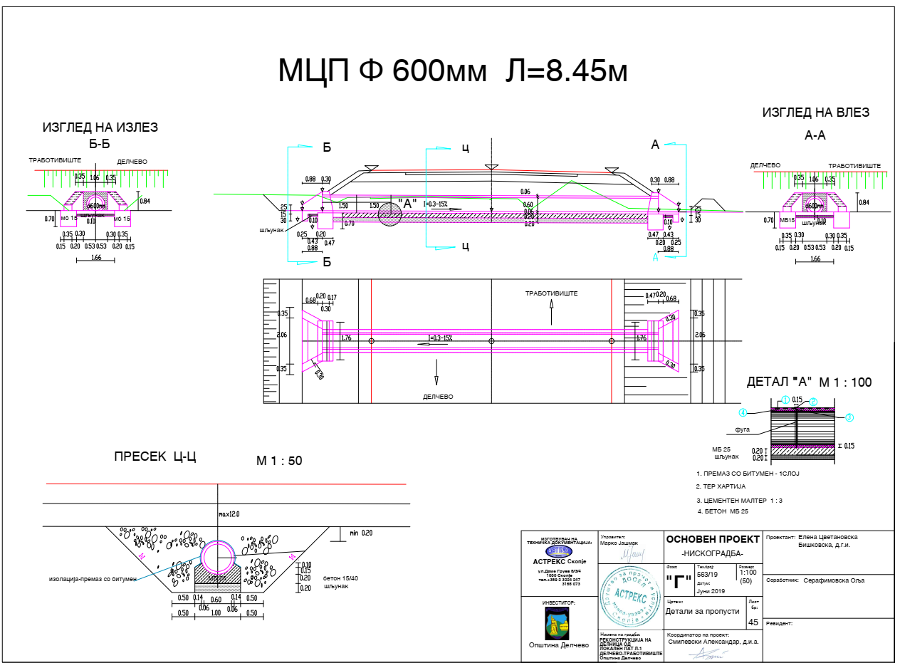

Graphic figures of the layout of relevant local road Delcevo – Trabotivishte, Municipality of Delcevo

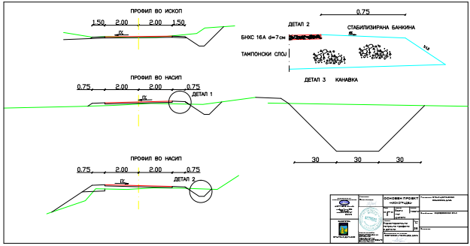

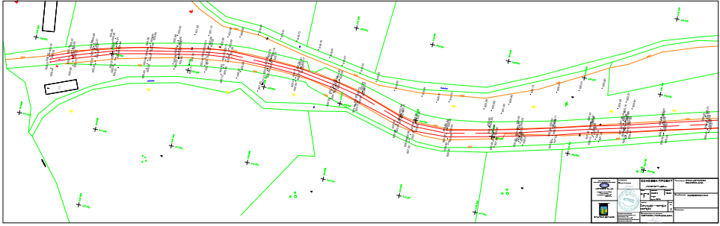

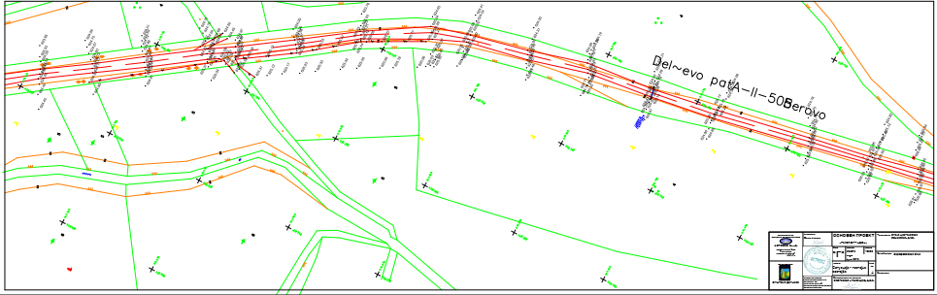

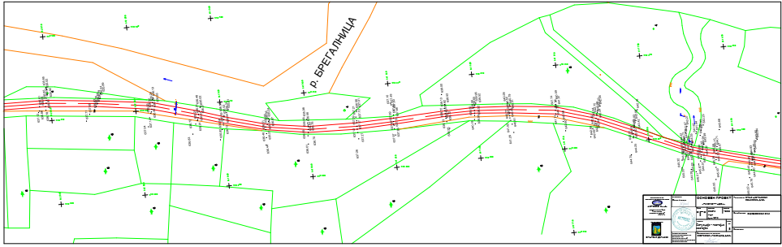

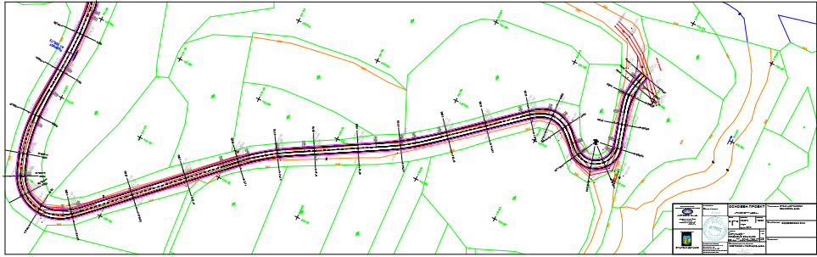

Annex 3 COVID-19 considerations in construction/civil works projects

Taking into account the new situation with the appearance of the virus COVID 19, besides the standard measures for safety and protection at work it is necessary to implement measures for protection from COVID 19.

Undoubtedly, the Contractors will face many challenges in the new situation, such as:

* Inability to purchase protective equipment and disinfectants due to lack on the market,
* Lack of labour due to limited movement and absences from work,
* Inability to provide materials and work equipment due to congestion in all segments of life in the country,
* Employees' concerns about their livelihoods due to reduced workload, etc.

First, it is necessary to implement the measures for protection from COVID 19 adopted by the Government of the Republic of Northern Macedonia at the proposal of the Commission for Infectious Diseases and the Ministry of Health. **These measures should be constantly updated in accordance with the latest provisions introduced by the Government**. The Contractor is required to nominate a responsible person who will follow the measures adopted by the Government and will apply them in the operation of the construction site at the project location.

Links of the national institutions responsible for COVID 19 where the Contractor could find updated information and recommendations:

* **Government of the Republic of North Macedonia -** [**https://vlada.mk/node/20488?ln=en-gb**](https://vlada.mk/node/20488?ln=en-gb)
* **Ministry of Health -** [**http://zdravstvo.gov.mk/korona-virus/**](http://zdravstvo.gov.mk/korona-virus/)
* **Ministry of Labour and Social Policy -** [**http://mtsp.gov.mk/covid-19.nspx**](http://mtsp.gov.mk/covid-19.nspx)
* **Ministry of transport and communications -** [**http://mtc.gov.mk/Preporaki%20od%20Vlada**](http://mtc.gov.mk/Preporaki%20od%20Vlada)
* **Official site for COVID – 19 -** [**https://koronavirus.gov.mk/en**](https://koronavirus.gov.mk/en)

On national level in addition to the measures introduced by the Government for protection from COVID 19, the Macedonian Occupational Safety and Health Association developed a Guide to Safety and Health at Work in Construction Prevention from the Corona virus. The Guide contains measures that the Contractor is required to implement in order to eliminate the possible ways of obtaining and transmitting COVID 19 among the workers on construction site.

In more detail in several chapters, the Guide contains:

* Challenges in construction;
* Obligations for the Contractor;
* Obligations for workers;
* Liabilities for Investors;
* Ways of proceeding in cases of suspected case or cases infected with COVID 19;
* Contact phones of national institutions responsible for contacting the occurrence of the event infected with COVID 19.

The text of the Guide to Safety and Health at Work in Construction Prevention from the Corona virus on the Macedonian language is given on the following link <http://mzzpr.org.mk/wp-content/uploads/2020/04/covid19-%D0%B3%D1%80%D0%B0%D0%B4%D0%B5%D0%B6%D0%BD%D0%B8%D1%88%D1%82%D0%B2%D0%BE.pdf>.

**The Contractor also needs to implement the requirements introduced by the World Bank related to the protection of COVID 19.**

Regarding the COVID-19 considerations in construction/civil works projects given by the World Bank, they are divided in several segments/issues and in details are shown on Table 3.

Table 3 COVID-19 considerations in construction/civil works projects recommended by WB

| **COVID-19 considerations in construction/civil works projects** | |
| --- | --- |
| **Covid-19 issues** | **Type of activities** |
| The Contractor should identify measures to address the COVID-19 situation taking into account the location, existing project resources, availability of supplies, capacity of local emergency/health services, the extent to which the virus already exist in the area.  PIU and Contractor should establish specific procedures for addressing COVID 19 issues on the construction site. Procedures should be implemented, documented and updated in accordance with the latest changes introduced by the Government and the conditions on the construction site. | |
| Assessing workforce characteristics | • The Contractor should prepare a detailed profile of the project work force, key work activities, schedule for carrying out such activities, different durations of contract and rotations;  • This should include a breakdown of workers who reside at home (i.e. workers from the community), workers who lodge within the local community and workers in on-site accommodation (i.e. workers camp). Where possible, it should also identify workers that may be more at risk from COVID-19, those with underlying health issues or who may be otherwise at risk;  • Consideration should be given to ways in which to minimize movement in and out of site. This could include lengthening the term of existing contracts, to avoid workers returning home to affected areas, or returning to site from affected areas. |
| Entry/exit to the work site and checks on commencement of work | • Establishing a system for controlling entry/exit to the site, securing the boundaries of the site, and establishing designating entry/exit points (if they do not already exist). Entry/exit to the site should be documented;  • Training security staff on the (enhanced) system that has been put in place for securing the site and controlling entry and exit, the behaviors required of them in enforcing such system and any COVID -19 specific considerations;  • Training staff who will be monitoring entry to the site, providing them with the resources they need to document entry of workers, conducting temperature checks and recording details of any worker that is denied entry;  • Confirming that workers are fit for work before they enter the site or start work. While procedures should already be in place for this, special attention should be paid to workers with underlying health issues or who may be otherwise at risk. Consideration should be given to demobilization of staff with underlying health issues;  • Checking and recording temperatures of workers and other people entering the site or requiring self-reporting prior to or on entering the site;  • Providing daily briefings to workers prior to commencing work, focusing on COVID-19 specific considerations including cough etiquette, hand hygiene and distancing measures, using demonstrations and participatory methods;  • During the daily briefings, reminding workers to self-monitor for possible symptoms (fever, cough, and other respiratory symptoms) and to report to their supervisor or the COVID-19 focal point if they have symptoms or are feeling unwell;  • Preventing a worker from an affected area or who has been in contact with an infected person from returning to the site for 14 days or (if that is not possible) isolating such worker for 14 days;  • Preventing a sick worker from entering the site, referring them to local health facilities if necessary or requiring them to isolate at home for 14 days. |
| General hygiene | • Placing posters and signs around the site, with images and text in local languages (MK/ALB);  • Ensuring handwashing facilities supplied with soap, disposable paper towels and closed waste bins exist at key places throughout site, including at entrances/exits to work areas; where there is a toilet, canteen or food distribution, or provision of drinking water; in worker accommodation; at waste stations; at stores; and in common spaces. Where handwashing facilities do not exist or are not adequate, arrangements should be made to set them up. Alcohol based sanitizer (if available, 60-95% alcohol) can also be used;   * Training workers and staff on site on the signs and symptoms of COVID-19, how it is spread, how to protect themselves (including regular handwashing and social distancing) and what to do if they or other people have symptoms;   • Setting aside part of worker accommodation for precautionary self-quarantine as well as more formal isolation of staff who may be infected. |
| Cleaning and waste disposal | • Providing cleaning staff with adequate cleaning equipment, materials and disinfectant;  • Training cleaning staff on appropriate cleaning procedures and appropriate frequency in high use or high-risk areas;  • Where it is anticipated that cleaners will be required to clean areas that have been or are suspected to have been contaminated with COVID-19, providing them with appropriate PPE: gowns or aprons, gloves, eye protection (masks, goggles or face screens) and boots or closed work shoes. If appropriate PPE is not available, cleaners should be provided with best available alternatives;  • Training cleaners in proper hygiene (including handwashing) prior to, during and after conducting cleaning activities; how to safely use PPE (where required); in waste control (including for used PPE and cleaning materials);  • Any medical waste produced during the care of ill workers should be collected safely in designated containers or bags and treated and disposed of following relevant requirements (e.g., national - <http://www.moepp.gov.mk/?nastani=%d0%bf%d1%80%d0%b5%d0%bf%d0%be%d1%80%d0%b0%d0%ba%d0%b8-%d0%b7%d0%b0-%d1%83%d0%bf%d1%80%d0%b0%d0%b2%d1%83%d0%b2%d0%b0%d1%9a%d0%b5-%d1%81%d0%be-%d0%be%d1%82%d0%bf%d0%b0%d0%b4-%d0%b7%d0%b0-%d0%b3%d1%80>,  WHO). If open burning and incineration of medical wastes is necessary, this should be for as limited a duration as possible. Waste should be reduced and segregated, so that only the smallest amount of waste is incinerated. |
| Adjusting work practices | • Decreasing the size of work teams;  • Limiting the number of workers on site at any one time;  • Changing to a 24-hour work rotation;  • Adapting or redesigning work processes for specific work activities and tasks to enable social distancing, and training workers on these processes;  • Continuing with the usual safety trainings, adding COVID-19 specific considerations. Training should include proper use of normal PPE. While as of the date of this note, general advice is that construction workers do not require COVID-19 specific PPE, this should be kept under review;  • Arranging (where possible) for work breaks to be taken in outdoor areas within the site;  • Consider changing canteen layouts and phasing meal times to allow for social distancing and phasing access to and/or temporarily restricting access to leisure facilities that may exist on site, including gyms;  • At some point, it may be necessary to review the overall project schedule, to assess the extent to which it needs to be adjusted (or work stopped completely) to reflect prudent work practices, potential exposure of both workers and the community and availability of supplies, taking into account Government advice and instructions. |
| Project medical services | • Expanding medical infrastructure and preparing areas where patients can be isolated. Isolation facilities should be located away from worker accommodation and ongoing work activities. Where possible, workers should be provided with a single well-ventilated room (open windows and door). Where this is not possible, isolation facilities should allow at least 1 meter between workers in the same room, separating workers with curtains, if possible. Sick workers should limit their movements, avoiding common areas and facilities and not be allowed visitors until they have been clear of symptoms for 14 days. If they need to use common areas and facilities (e.g. kitchens or canteens), they should only do so when unaffected workers are not present and the area/facilities should be cleaned prior to and after such use.  • Training medical staff, which should include current WHO advice on COVID-19 and recommendations on the specifics of COVID-19. Where COVID-19 infection is suspected, medical providers on site should follow WHO interim guidance on infection prevention and control during health care when novel coronavirus (nCoV) infection is suspected;  • Assessing the current stock of equipment, supplies and medicines on site, and obtaining additional stock, where required and possible. This could include medical PPE, such as gowns, aprons, medical masks, gloves, eye protection, etc..;  • Review existing methods for dealing with medical waste, including systems for storage and disposal. |
| Local medical and other services | • Conducting preliminary discussions with specific medical facilities, to agree what should be done in the event of ill workers needing to be referred;   * Obtaining information as to the resources and capacity of local medical services (e.g. number of beds, availability of trained staff and essential supplies);   • Clarifying the way in which an ill worker will be transported to the medical facility, and checking availability of such transportation;  • Agreeing with the local medical services/specific medical facilities the scope of services to be provided, the procedure for in-take of patients and (where relevant) any costs or payments that may be involved;  • A procedure should also be prepared so that project management knows what to do in the unfortunate event that a worker ill with COVID-19 dies. While normal project procedures will continue to apply, COVID-19 may raise other issues because of the infectious nature of the disease. The project should liaise with the relevant local authorities to coordinate what should be done, including any reporting or other requirements under national law; |
| Instances or spread of the virus | **• If a worker has symptoms of COVID-19 (e.g. fever, dry cough, fatigue) the worker should be removed immediately from work activities and isolated on site;**  **• The worker should be transported to the local health facilities to be tested (if testing is available and permitted under national legislation);**  **• If the test is positive for COVID-19 or no testing is available, the worker should continue to be isolated. This will either be at the work site or at home. If at home, the worker should be transported to their home in transportation provided by the project;**  **• Extensive cleaning procedures with high-alcohol content disinfectant should be undertaken in the area where the worker was present, prior to any further work being undertaken in that area. Tools used by the worker should be cleaned using disinfectant and PPE disposed of;**  **• Co-workers (i.e. workers with whom the sick worker was in close contact) should be required to stop work, and be required to quarantine themselves for 14 days, even if they have no symptoms;**  **• Family and other close contacts of the worker should be required to quarantine themselves for 14 days, even if they have no symptoms;**  **• If a case of COVID-19 is confirmed in a worker on the site, visitors should be restricted from entering the site and worker groups should be isolated from each other as much as possible;**  **• If workers live at home and has a family member who has a confirmed or suspected case of COVID-19, the worker should quarantine themselves and not be allowed on the project site for 14 days, even if they have no symptoms;**  **• Workers should continue to be paid throughout periods of illness, isolation or quarantine, or if they are required to stop work, in accordance with national law;**  **• Medical care (whether on site or in a local hospital or clinic) required by a worker should be paid for by the employer.** |
| Continuity of supplies and project activities | • Identify back-up individuals, in case key people within the project management team (PIU, Supervising Engineer, Contractor, sub-contractors) become ill, and communicate who these are so that people are aware of the arrangements that have been put in place;  • Document procedures, so that people know what they are, and are not reliant on one person’s knowledge;  • Understand the supply chain for necessary supplies of energy, water, food, medical supplies and cleaning equipment, consider how it could be impacted, and what alternatives are available. Early pro-active review of international, regional and national supply chains, especially for those supplies that are critical for the project, is important (e.g. fuel, food, medical, cleaning and other essential supplies). Planning for a 1-2 month interruption of critical goods may be appropriate for projects in more remote areas;  • Place orders for/procure critical supplies. If not available, consider alternatives (where feasible);  • Consider existing security arrangements, and whether these will be adequate in the event of interruption to normal project operations;  • Consider at what point it may become necessary for the project to significantly reduce activities or to stop work completely, and what should be done to prepare for this, and to re-start work when it becomes possible or feasible. |
| Contingency planning for an outbreak | The contingency plan to be developed at each site should set out what procedures will be put in place in the event of COVID-19 reaching the site. The contingency plan should be developed in consultation with national and local healthcare facilities and follow state guidance for COVID-19 response, to ensure that arrangements are in place for the effective containment, care and treatment of workers who have contracted COVID-19. The contingency plan should also consider the response if a significant number of the workforce become ill, when it is likely that access to and from a site will be restricted to avoid spread.  Contingencies should be developed and communicated to the workforce for:  • Isolation and testing procedures for workers (and those they have been in contact with) that display symptoms;  • Care and treatment of workers, including where and how this will be provided;  • Getting adequate supplies of water, food, medical supplies and cleaning equipment in the event of an outbreak on site, especially should access to the site become restricted or movements of supplies limited.  Specifically, the plan should set out what will be done if someone may become ill with COVID-19 at a worksite. The plan should:  • Set out arrangements for putting the person in a room or area where they are isolated from others in the workplace, limiting the number of people who have contact with the person and contacting the local health authorities;  • Consider how to identify persons who may be at risk (e.g. due to a pre-existing condition such as diabetes, heart and lung disease, or as a result of older age), and support them, without inviting stigma and discrimination into your workplace; and  • Consider contingency and business continuity arrangements if there is an outbreak in a neighboring community.  Contingency plans should consider arrangements for the storage and disposal arrangements for medical waste, which may increase in volume and which can remain infectious for several days (depending upon the material). The support that site medical staff may need, as well as arrangements for transporting (without risk of cross infection) sick workers to intensive care facilities or into the care of national healthcare facilities should be discussed and agreed.  Contingency plans should also consider how to maintain worker and community safety on site should sites closed to comply with national or corporate policies, should work be suspended or should illness affect significant numbers of the workforce. It is important that worksite safety measures are reviewed by a safety specialist and implemented prior to work areas being stopped. |
| Training and communication with workers | • Regular information and engagement with workers (e.g. through training, town halls, tool boxes) that emphasizes what management is doing to deal with the risks of COVID-19. Workers should be given an opportunity to ask questions, express their concerns, and make suggestions;  • Training should address issues of discrimination or prejudice if a worker becomes ill and provide an understanding of the trajectory of the virus, where workers return to work;  • Training should cover all issues that would normally be required on the work site, including use of safety procedures, use of construction PPE, occupational health and safety issues, and code of conduct, taking into account that work practices may have been adjusted;  • Communications should be clear, based on fact and designed to be easily understood by workers, for example by displaying posters on handwashing and social distancing, and what to do if a worker displays symptoms. |
| Communication and contact with the community | • Communications should be clear, regular, based on fact and designed to be easily understood by community members;  • Communications should utilize available means. In most cases, face-to-face meetings with the community or community representatives will not be possible. Other forms of communication should be used; online platforms, social media, posters, pamphlets, radio, text messages, virtual meetings. The means used should take into account the ability of different members of the community to access them, to make sure that communication reaches these groups;  • The community should be made aware of procedures put in place at site to address issues related to COVID-19. This should include all measures being implemented to limit or prohibit contact between workers and the community. The community should be made aware of the procedure for entry/exit to the site, the training being given to workers and the procedure that will be followed by the project if a worker becomes sick. |
| Covid-19 reporting | Contractor should report an outbreak for a ‘Serious’ incident. The Contractor should keep the Borrower informed of any concerns or problems associated with providing care to infected workers on project sites, particularly if infection rate is approaching 50% of the workforce. |

Annex 4 Form for submitting comments

|  |  |  |
| --- | --- | --- |
| **Form for submitting comments and suggestions for Environmental and Social Management Plan ESMP for the project “Upgrading of local road L-1 connecting Delcevo - Trabotivishte, in Municipality of Delcevo**  **Main description of the project**  The project road is connecting the city of Delcevo with the settlemnts Trabotivishte and Razlovci, located in the eastern part of the Municipality of Delcevo. The total length of the road is 5,3 km. The main activities for this sub-projectare: marking out and clearing up of the project site, installation of crushed stone material, putting asphalt layer, etc. Since this are an existing roads, no significant environmental impacts are expected, but for the identified impacts, the ESMP is prepared where appropriate measures for their mitigation and minimization are prescribed.  **Electronic version of Environmental and Social Management Plan (ESMP) for the project “Upgrading of local road L-1 connecting Delcevo - Trabotivishte, in Municipality of Delcevo is available on the following web pages**:   * Municipality of Delcevo: www.delcevo.gov.mk * MoTC PIU: http://mtc.gov.mk/ | | |
| **Name and surname of the person who provides comment\*** |  | |
| **Contact information\*** | **E-mail:**  ______________________________  **Phone:**  _____________________________ | |
| **Comment on the ESMP:** | | |
| **Signature**  ______________________ | | **Date**  ____________________ |
| **If you have any comments/suggestions or amendments to the proposed measures of Environmental and Social Management Plan ESMP for the project “Upgrading of local road L-1 connecting Delcevo - Trabotivishte, in Municipality of Delcevo, please submit it to the responsible persons from the following institution:**  **Contact person: Irena Paunovikj**  **e-mail: irena.paunovikj.piu@mtc.gov.mk**  **Within the 14 days period after the announcement of ESMP for the project “Upgrading of local road L-1 connecting Delcevo – Trabotivishte”, in Municipality of Delcevo**  **(date of announcement: ……. )** | | |
| **Referent number: ______________________________**  (fulfilled by the responsible persons for the project implementation) | | |

* Fulfillment of the fields with personal data is not obligatory

Annex 5 Grievance Form for whole project implementation period

|  |  |  |
| --- | --- | --- |
| **Reference Number** |  | |
| **Full name (optional)**   * **I wish to raise my grievance anonymously.** * **I request not to disclose my identity without my consent.** |  | |
| **Contact information**  **Please mark how you wish to be contacted (by post, telephone, e-mail).** | * **By Post: *Please provide mailing address:***   **________________________________________________________________________________________________________________________________________________________________________**   * **By telephone: ___________________________________________________** * **By E-mail** | |
| **Preferred language of communication** | * **Macedonian** * **Albanian** * **Turkish** * **Other: ____________________** | |
| **Gender** | * **Female** * **Male** | |
|  | | |
| **Description of Incident for Grievance** | | What happened? Where did it happen? Whom did it happen to? What is the result of the problem? |
|  | | |
| **Date of Incident / Grievance** |  | |
|  | * **One-time incident/grievance (date ________________)** * **Happened more than once (how many times? ______)** * **On-going (currently experiencing problem)** | |
|  | | |
| **What would you like to see happen?** | | |
|  | | |

Signature: _______________________________

Date: _______________________________

*Please return this form to:*

|  |  |  |  |
| --- | --- | --- | --- |
| Name and surname | Irena Paunovikj | Toni Vangelovski | *------------------------* |
| E-mail | irena.paunovikj.piu@mtc.gov.mk | tonivangelovski@gmail.com | *--------------------------------* |
| Institution | Ministry of Transport and communications | Municipality of Delcevo | Contractor Company |

Local Roads Connectivity Project

St. Dame Gruev 6,1000 Skopje, R. N. Macedonia